Physics Olympics
Pasta-Mobile

Design Event
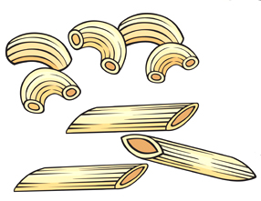
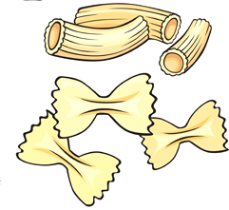
Objective: To construct a vehicle entirely out of dry pasta and glue that, when released from the top of a ramp, will travel the greatest horizontal distance away from the bottom of the ramp, within a 1.5m wide "lane", before stopping.
Rules & Requirements: Any supermarket variety dry, uncooked pasta may be used. Samples of the pasta used should be brought in the event of a challenge. Any commercially available glue is permissible. Only minimal use of glue is allowed. No major "sculpting", joint, or gap ﬁlling with glue will be allowed. The pasta may be shaped by filing, sanding, or other dry machining techniques.
The vehicle must be able to fit into a closed box 30cm x 20cm x 15cm. There are no mass restrictions. The device must make and maintain contact with the surface on which it rests at more than one point/segment. (Simple spheres & cylinders will not be acceptable – the vehicle cannot simply be one rigid mass - it must contain parts that move independently.)
**Teams are responsible for providing their own ramps for launch. The ramps must be static objects that contain no moving parts. The ramps must fit in a space that is 1 meter high x 1 meter long x 0.5 meters wide.
Competition: The pasta mobiles will be placed on the ramp so that the rearmost part of the racer is in line with the highest point on the ramp. The cart will then be released by the contestant (no helpful nudges allowed!) Each group will be allowed to do two launches, and the best launch will be considered for scoring.
Scoring: Scores will be based on:
Presentation of a pasta-mobile that meets the specifications as outlined above. Pasta-mobiles not meeting the requirements will be disqualified.
The distance from the bottom of ramp the pasta-mobile is able to travel horizontally, within the 1.5m lane.
Should the pasta-mobile lose its structural integrity (fall apart) during its run, the distance will be determined by the largest surviving structural component.
The highest scores will be awarded to pasta-mobiles that remain basically intact and travel the greatest distances, followed by those that do not remain intact but do meet all other requirements. lf the pasta-mobile rolls outside of the 1.5m wide lane, its distance will be measured along the edge of the lane to the first point where any part of the pasta-mobile crossed the boundary line.

